**Monitoring urban litter loads in South Africa during the Covid-19 lockdown – Results for PAN-Environment**

By Peter G. Ryan, Kyle Maclean and Eleanor A. Weideman

FitzPatrick Institute of African Ornithology, DSI-NRF Centre of Excellence, University of Cape Town, Rondebosch, 7701, South Africa

On 27 March 2020, South Africa entered a hard lockdown during which people were only allowed to leave their home to buy food, seek medical attention or provide a limited set of essential services. This strict ‘Level 5’ lockdown was imposed until the end April 2020 and was eased to ‘Level 4’ from 1 May 2020, during which people could exercise within 5 km of their homes but only between 6h00-9h00. From 1 June, the country moved to ‘Level 3’ under which most businesses re-opened and which saw much greater freedom of movement.

We were issued permits to conduct street litter surveys from 20 April 2020. We thoroughly cleaned 400 m of street in Muizenberg (Cape Town) and Kloof (Durban) and conducted daily litter collections every day for 50 days from 22 April (Cape Town) and 23 April (Durban) to 10–11 June. This represented 8–9 days of Level 5 lockdown, 31 days of level 4 Lockdown and 10–11 days of Level 3 lockdown.

We used Generalised Linear Models to assess how the number of items collected per day changed as South Africa moved from Level 5 to Level 3. We fit two models: the first modelled the number of litter items per day as a function of day (from day 1 to 50) while the second modelled the number of items per day as a function of lockdown level (levels 5, 4 and 3). Both models were fit with a quasi-Poisson distribution to account for the data being overdispersed and each site (Cape Town and Durban) was modelled separately. Litter mass also was recorded, and showed similar patterns, but with greater variance due to the influence of a few heavy items. We only present count data here.

**Model 1: # items per day ~ day**

There was a significant increase in litter loads at both sites as the lockdown progressed (see screenshots of the model outputs below). Litter loads increased by 3.43% per day in Cape Town and 2.57% per day in Durban.

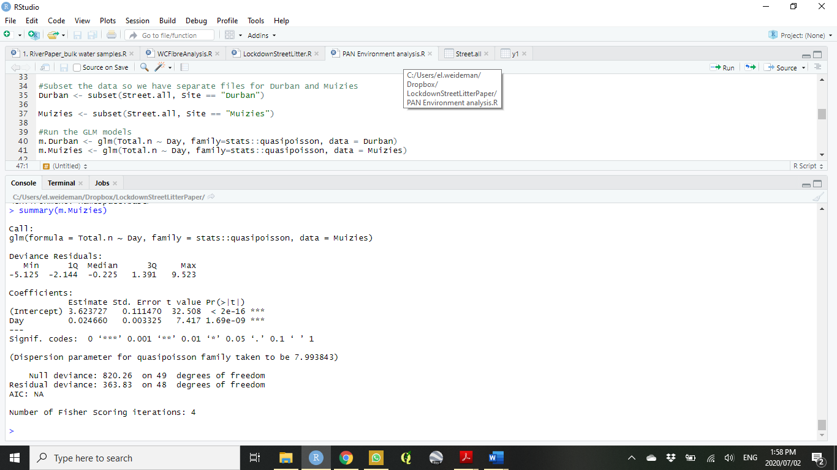Screenshot 1: Model output for Cape Town. The number of litter items per day was modelled as a function of day and was fit with a quasi-Poisson distribution.

Screenshot 2: Model output for Durban. The number of litter items per day was modelled as a function of day and was fit with a quasi-Poisson distribution.

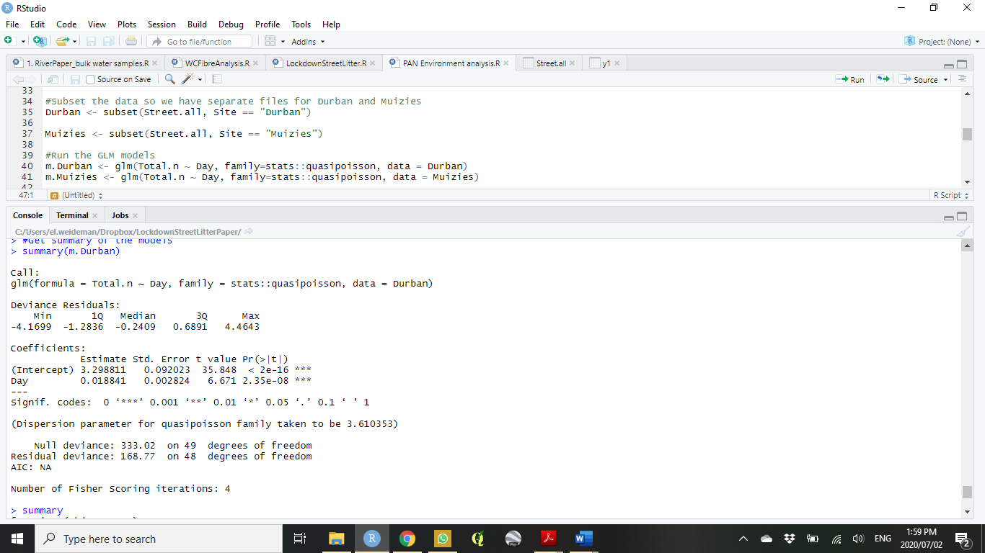

**Model 2: # items per day ~ lockdown level**

When modelled using the categorical variable of lockdown level, litter loads were significantly higher in both Level 3 and 4 than in Level 5 (the hard lockdown; see screenshots below). In Cape Town, litter loads were 1.79 times more abundant in Level 4 than in level 5, and 3.27 times more abundant in Level 3 than level 5. In Durban, litter loads were 1.74 times higher in Level 4 than in level 5, and 2.44 times more abundant in level 3 than level 5

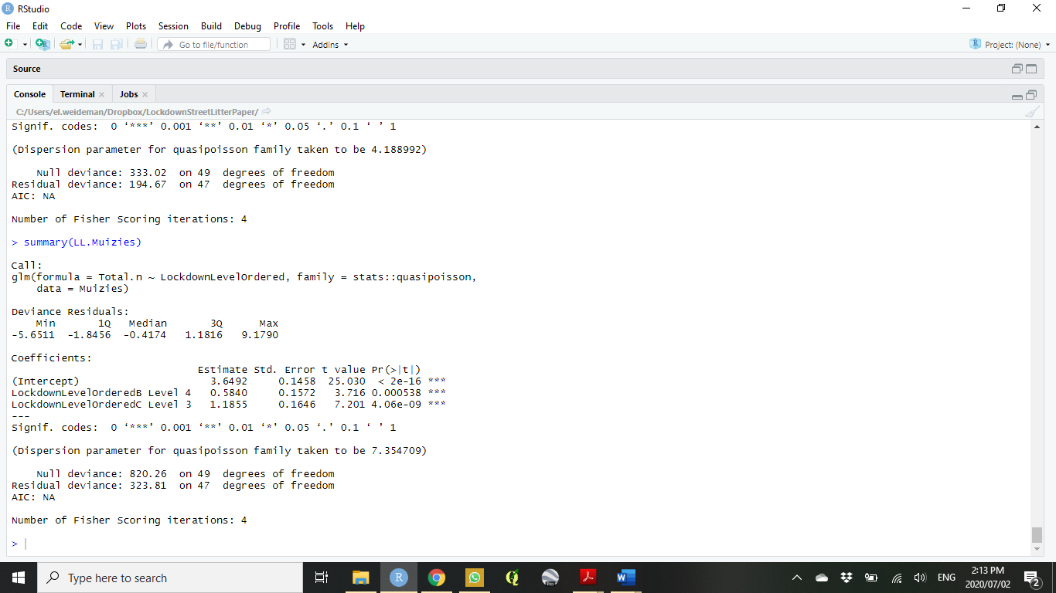Screenshot 3: Model output for Cape Town. The number of litter items per day was modelled as a function of lockdown level and was fit with a quasi-Poisson distribution.

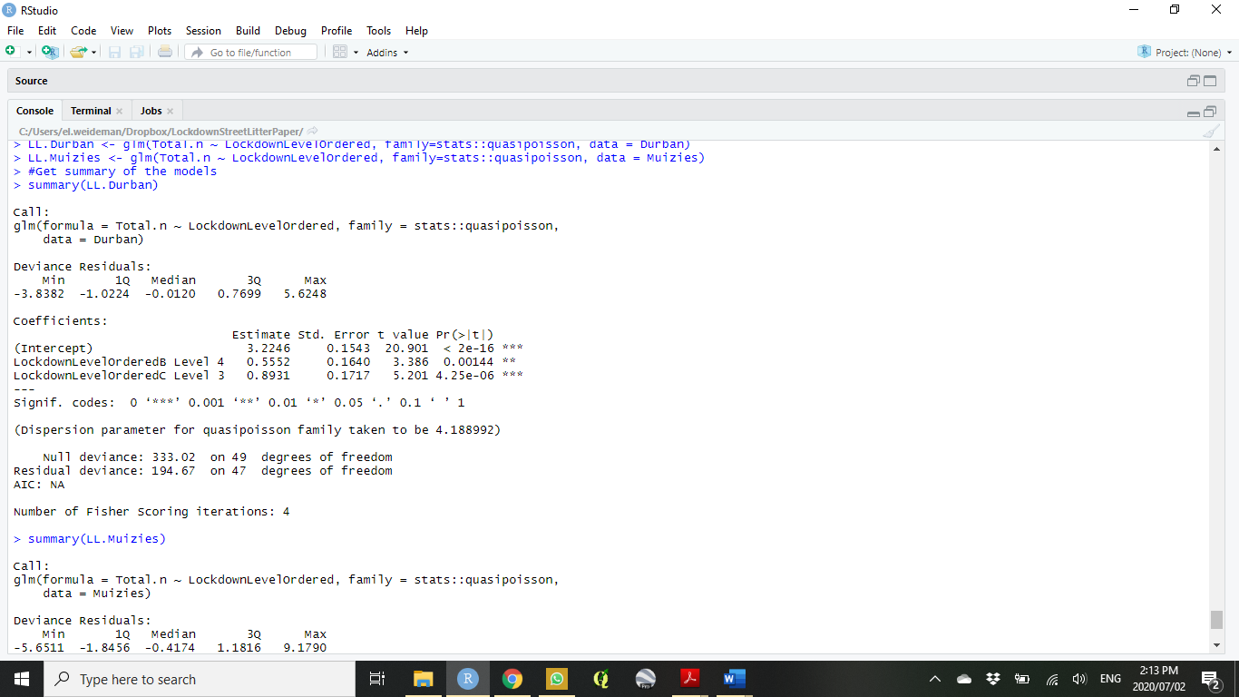Screenshot 4: Model output for Durban. The number of litter items per day was modelled as a function of lockdown level and was fit with a quasi-Poisson distribution.